**ENGI 5631: Signal and Image processing in Biomedical Applications**

**Ultrasound Laboratory: TEAM 3**

**INTRODUCTION: Referred teammates.**

Ultrasound is one of the most widely used modalities in medical imaging. Ultrasound imaging is regularly used in cardiology, obstetrics, gynecology, abdominal imaging, etc. Its popularity arises from the fact that it provides high-resolution images without the use of ionizing radiation. It is also mostly non-invasive, although an invasive technique like intra-vascular imaging is also possible. Non-diagnostic use of ultrasound is finding increased use in clinical applications, (e.g., in guiding interventional procedures). There are also novel non-imaging uses of ultrasound like bone densitometer where the ultrasound speed difference is used to measure the depth or width of bones non-invasively. Ultrasound systems are signal processing intensive. With various imaging modalities and different processing requirements in each modality, digital signal processors (DSP) are finding increasing use in such systems. The advent of low power system-on-chip (SOC) with DSP and RISC processors is allowing OEMs to provide portable and low-cost systems without compromising the image quality necessary for clinical applications.

**METHODS**:

Two other types of ultras­ound are currently in use,

1.2-d &3-D ultrasound imaging

2.Doppler ultrasound

**Procedure:**

Team3: Initially the target is allowed to be placed in the exact position then the target is allowed to come in contact with the scanner. Jell is applied on the target or the target is kept in water. To acquire the data the parameters are changed and position of the probe scanner is also changed. We can get the observations on the target. Later data can be retrived.

**RESULTS**:

<https://github.com/snehapatnam/lab>

**Ultrasound rendering:**

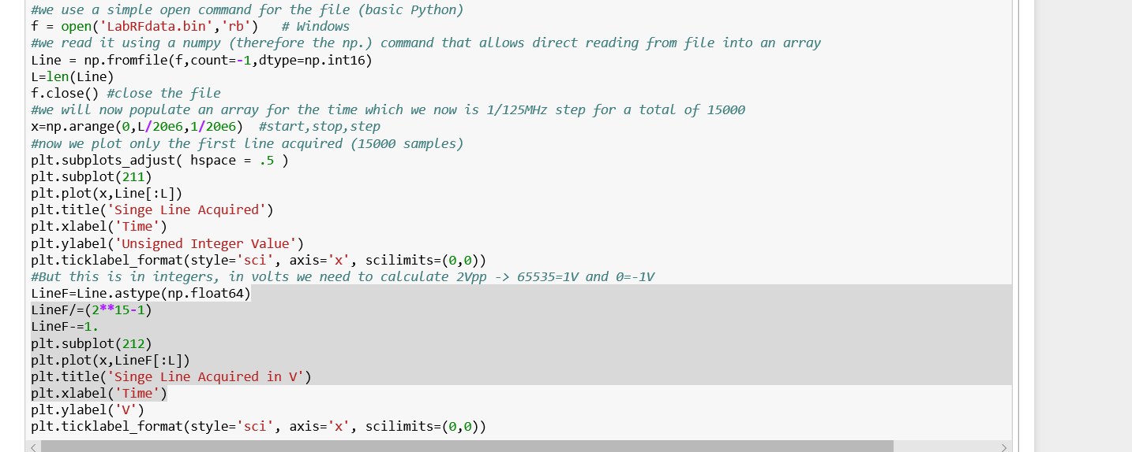

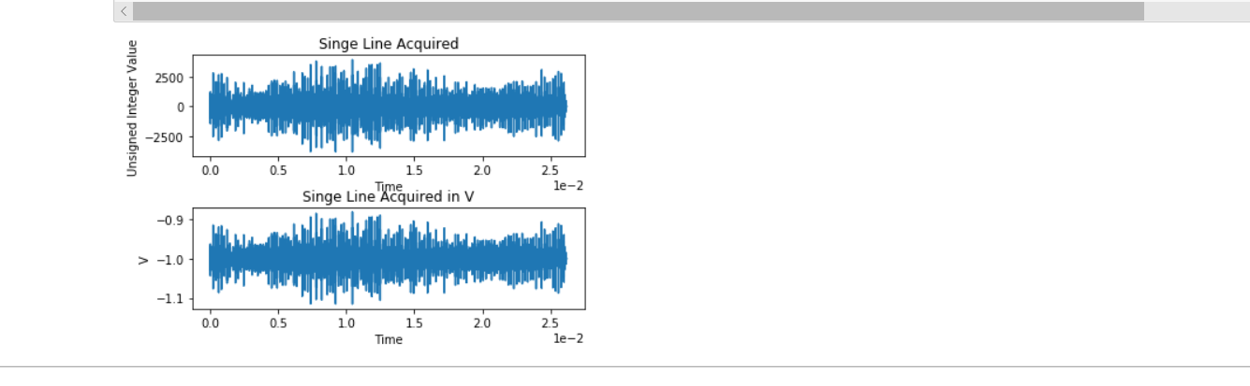

**FREQUENCY:**

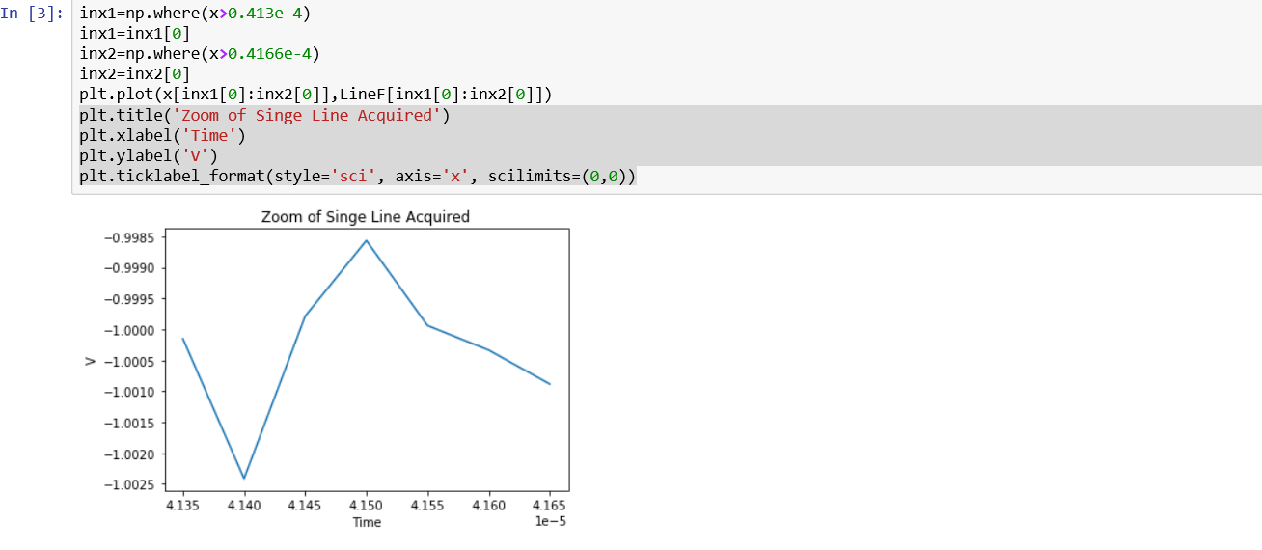



**BANDWIDTH:**

B.W = F2-F1

= (0.4166-0.413) *10^-4 = 0.036*10^-4 =0.3µhz

**ACQUSITION PARAMETERS:**

1. Voltage (0 to 10v)

As voltage increases, they are big excitation of images

1. TGC :As gain increase we get strings in the image

As gain decreases we don’t get any strings in the image

1. Sound: As speed of sound increases the effects of image increases
2. Sensitive Cut-off (0.917) where cut-off is 60%, we don’t get image
3. Range(89mm) where the acquisition decreases the area of image

**DICOM US-Mono-2-8-8x-execho.dcm:**

To render the image in the given DICOM example we need to do few changes in the code. First thing is to change the file name and to render the image we are taking 8Bits so we are going to change the code

constpixelDims=(int(Refds,Bitsstored),int(refds.Rows),int(Refds,Coloumns)

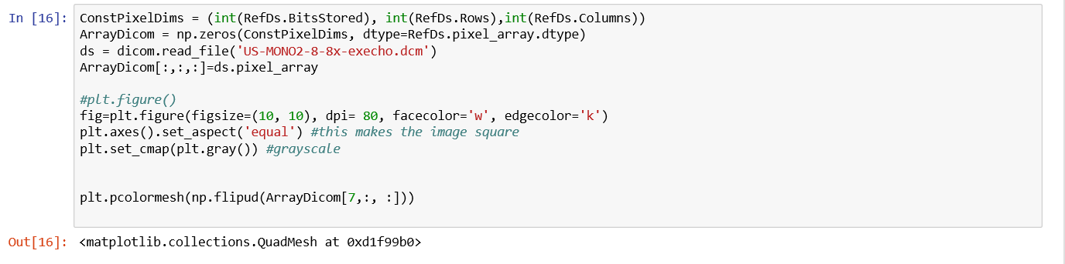

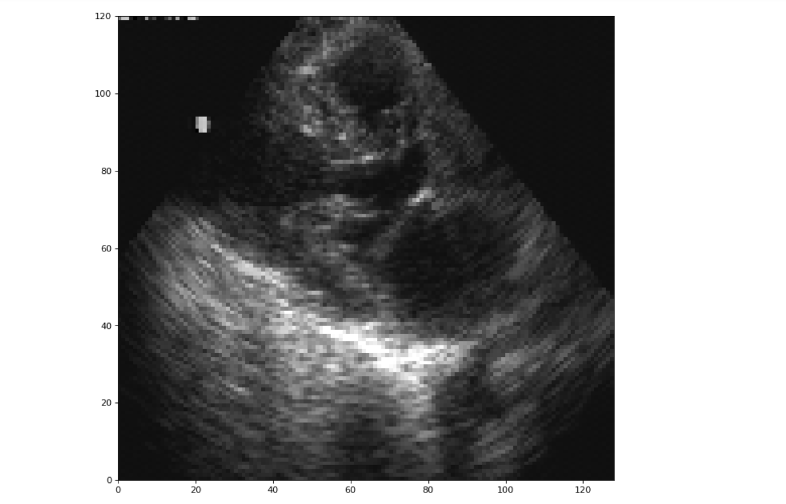

**DISCUSSION:**

 DICOM stands for **D**igital **I**maging and **CO**mmunication in **M**edicine. It is the standardin medicine for image exchange. It allows to have medical information in the images as a standard file that is independent from the manufacturer.

DICOM is used to collect the original medical images to get the accurate images. DICOM to send, distribute, and store images, irrespective of machine, manufacturer, or modality. It is simple multiplanar reconstruction, or more advanced perfusion analysis, virtual colonoscopy, volume segmentation, or computer-aided diagnosis.

**REFERENCES:**

1. Burckhardt, C. B. "Signal processing in ultrasound imaging, Doppler and Doppler imaging." *Ultraschall in der Medizin (Stuttgart, Germany: 1980)* 14.5 (1993): 220-224.
2. ‘*A Computer-Controlled Ultrasound Pulser-Receiver System for Transkull Fluid Detection using a Shear Wave Transmission Technique*’ by Sai Chun Tang ,Gregory T.Clement and Kullervo Hynninen in IEEE Trans Ultrason Ferroelectr Freq Control. 2007 Sep